COURSE SPECIFICATION DOCUMENT

Academic School / Department: School of Science, Innovation, and Technology

Programme: Computer Science

FHEQ Level: 6

Course Title: Senior Project

Course Code: COMP 6110

Instructor: Sevinj Teymurova
Email:

Total Hours: 320

Timetabled Hours: 0
Guided Learning Hours: 45
Independent Learning Hours: 275

Credits: 32 UK CATS credits
16 ECTS credits
8 US credits

Course Description:
This course is a student identified project. It provides the setting for students to
conceptualise, research, and propose a written brief that includes the identification and the
establishment of an appropriate methodology. The instructor will facilitate the process
through regularly scheduled class meetings.

The research will be an opportunity to independently plan and execute a project via a
literature review, project management and execution and the project will need to follow a
methodology explored in Data Science Research Methods in Computing.

Prerequisites:
COMP 5301 Research Methods in Data Science plus 70 credits

Aims and Objectives:
By the end of this course, students will have completed a substantial project that
demonstrates their employability skills in a computer science area of their interest. They will
start with a project concept, conduct the necessary research necessary to write a brief,
establish a methodology, complete the design, develop and evaluate. They will reflect on their
work critically to identify areas of improvement in their work.
Programme Outcomes:
AII, III, BI, II, CII, DI, II,
A detailed list of the programme outcomes are found in the Programme Specification. This
is located at the archive maintained by Registry and found at:
https://www.richmond.ac.uk/programme-and-course-specifications/

Learning Outcomes:
By the end of this course, successful students should be able to:
• Plan a technical project, aware of its scope and constraints.
• Independently carry out literature review of areas relevant to the subject.
• Evaluate the ethical and sustainable consequences of their project.
• Identify a methodology appropriate to the project brief.
• Implement a methodology appropriate to the project brief.
• Design and programme a response to meet the requirements of the brief.
• Evaluate the design and program at appropriate stages of the project.
• Critically reflect on their project and its implementation.

Indicative Content:
• Idea generation
• Writing a technical brief
• Approaches, methodologies and methods
• Writing literature reviews
• Implementation
• Findings and analysis
• Reflection and conclusions

Click here to enter text.
Assessment Criteria:
Assignment 1 | Presentation (30%) | Week 12
Assignment 2 | Dissertation (70%) | Week 13
Students will be instructed when to use AI for research and structuring but must not use AI for reflective writing. The written assessment must be accompanied by a declaration of AI use.
All assessment criteria conform with the University Assessment Norms found at https://www.richmond.ac.uk/university-policies/

Teaching Methodology:
This course will be delivered face to face through a combination of lectures and interactive sessions. In addition to classroom activities, there are guided learning elements that are tutor led and arranged through Blackboard. These activities can be asynchronous online sessions, flipped classrooms, set readings with discussion boards or set guest lectures for example. Set activities are monitored by the instructor to ascertain student engagement. Students are encouraged to prepare for class and to play an active part, to raise questions, following-up ideas and interact with a wide range of provided material.

ASSESSMENT NORMS
One or more assessment must be chosen from the columns labelled A-D
Any exception must be approved by the appropriate Head of School/Department.
Conditions
1. An individual exam (where included) should total no less than 25% and no more than 50% of the final grade. Lengths are indicative only.
2. Accounting norms require a total of 3 hours in class assessment and a final unseen exam that is worth 50% of the overall grade.
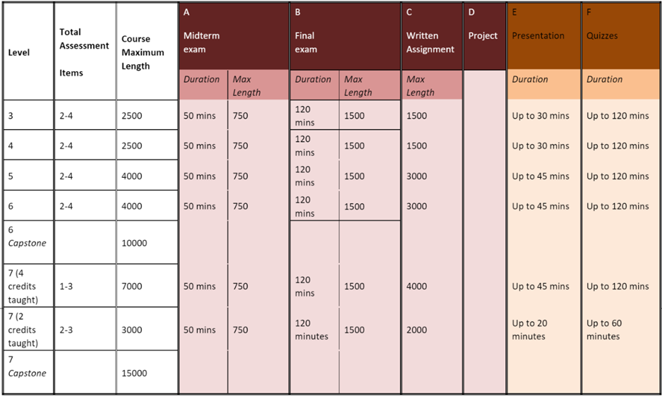

This class follows the Late Submission of Coursework Policy and Feedback Norms outlined below and found at https://www.richmond.ac.uk/university-policies/
When conducting research (including class-wide projects, senior seminars and personal research) using data gathered from human participants, all students and faculty members should consider that ethical approval for their work may be needed. Please consult the Richmond Ethics Committee Guidelines and Processes at https://www.richmond.ac.uk/faculty-research/
Questions may be directed to researchethics@richmond.ac.uk.
Marking Scheme:
All marking and grading follows the University’s Grading Policy for Undergraduates. Full details of Richmond’s Undergraduate Grading Policy are found at https://www.richmond.ac.uk/university-policies/

Each letter grade is assigned a numerical equivalent on the following scale for undergraduate study:
UNDERGRADUATE GRADING SCALE
Grade | GPA | Descriptor | Detailed Descriptor
A  A- | 4.0  3.666 | Excellent | Grade A applies only to work which:  - is of excellent to exceptional standard  - demonstrates in-depth knowledge and understanding  - demonstrates substantial work and original thought has been involved  - makes use of very high quality analysis, synthesis, evaluation and critical appraisal  - is organised and structured to a high standard  - goes beyond what was taught in the lectures
B+  B  B- | 3.333  3.0  2.666 | Good | Grade B applies to work which:  - is of good to very good standard  - demonstrates sound and good quality of knowledge and understanding  - demonstrates good quality analysis, synthesis, evaluation and critical appraisal  - indicates an increasing ability to incorporate meaning into the work and understand key theories, debates and criticisms  - is well organised and structured
C+  C | 2.333  2.0 | Satisfactory | Grade C applies to work which:  - is adequate although undeveloped  - fulfils the requirements of the project at a foundation level in terms of its quality, analysis and expression  - limited level of research and understanding of key theories and debates  - is organised and presented in a satisfactory form
C- | 1.666 | Below Average | - falls below the threshold criteria  - demonstrates limited knowledge and understanding  - demonstrates minimal attention to quality, range, and appropriateness of research  - normally passing grade at course level
D+  D  D- | 1.333  1.0  0.666 | Minimal Achievement | Grade D applies to work which:  - is of a poor standard  - has been produced without a proper understanding of the brief demonstrating confusion  - is weak in content and shows little evidence of thought or application  - relies on weak or superficial technique  - incorporates insufficient research and/or inappropriate sources  - is organised and presented poorly  - normally passing grade at course level
F | 0 | Fail | Grade F applies to work which:  - is of very poor standard  - has not been submitted or has been submitted beyond the project deadline  - shows a complete lack of content, thought or application  - makes no or insufficient use of analysis and relevant skills  - is the product of academic misconduct  - does not fulfill the brief  - failing grade at all levels
FA | 0 | Fail (Attendance) | Grade FA applies to work where:  - a student has breached the University’s Attendance Policy
FS | 0 | Fail (Non-Submission) | Grade FS applies to work which:  - has not been submitted or has been submitted beyond the project deadline
FX | 0 | Fail (Academic Misconduct) | Grade FX applies to work which:  - is the product of academic misconduct

Indicative Text(s):
- Dennis, Alan, Barbara Wixom, and Roberta Roth. 2015. Systems Analysis And Design : An Object–Oriented Approach with UML. 5th ed. Hoboken, NJ: Wiley.
- Greetham, B., 3rd edition, 2019 How to Write your Undergraduate Dissertation. Macmillan Study Skills
- Vickler, A., 2021. Java. New Mexico: Ladoo Publishing.

Journals/Additional Texts
- Bassot, B., 2015. The Reflective Practice Guide. Abingdon: Routledge.
- Bhatti, J., Corleissen, Z., Lambourne, J., Nunez, D. and Waterhouse, H., 2021. Docs For Developers. New York Apress.
- Cottrell, S., 2017. Critical Thinking Skills Effective Analysis, Argument And Reflection. Basingstoke: Palgrave.
- Hart, C., 2018. Doing A Literature Review. 2nd ed. London: Sage.
- Kendall, K. and Kendall, J., 2019. Systems Analysis And Design. 10th ed. Harlow: Pearson.

Web Sites

See syllabus for complete reading list

